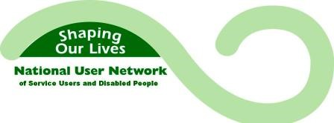
Shaping Our Lives Covid 19 Research Information Sheet
Name of project: The impacts of Covid-19 and the 2020 lockdown on Patient engagement and participation groups
Where it will take place: All research is being completed remotely.

Overview: Shaping Our Lives has been awarded a grant by the National Lottery Community Fund to complete some research about the longer term impacts of Covid-19 and lockdown on Disabled people, d/Deaf and Disabled People's Organisations and Patient engagement and participation groups.

Our network members have told us that they are concerned about getting back to their usual independence and confidence after lockdown. Some of the concerns are:
- Loss of confidence and anxiety about leaving home.
- Loss of independent living and mobility skills.
- Cancellation of operations and treatments.
- Needing help to use new remote meeting technology.
- Patient and service groups are not informing practice.
- Capacity pressures for local user-led groups.

Aims of the research: We want to be able to tell policy makers in health and social care services what longer term support and other considerations they need to make for Disabled people including:
- What support Disabled people may need to regain their confidence and independence.
- Understand how remote meeting technology can help (or not) Disabled people to take part and get their voice heard.
- Hear from d/Deaf and Disabled People's Organisations about their success or failure to get funding and the services people have needed because of Covid-19.
- Including patient groups in good decision making.

Participant involvement: There are two short surveys, some longer interviews, group discussions with d/Deaf and Disabled People's Organisations and interviews with senior representatives of patient groups. There is no involvement payment for completing a short survey; the short surveys should take about 15 minutes. For people who take part in a longer interview there is an involvement payment of £30 offered; longer interviews will take about one hour. For representatives of d/Deaf and Disabled People's Organisations who take part in a round table discussion there is an involvement payment of £30 offered.

How we will use the information: the information we collect will be written about in three reports and shared with health and social care providers. We will not use anyone's names or the name of organisations and services in the final reports. All personal information provided is confidential.

If you have any questions please contact
Becki Meakin, General Manager at Shaping Our Lives:
Mobile phone - 07956 424511
Email - becki@shapingourlives.org.uk

